Request 1: Project Description

Project Title: FPT Student Learning Management (SLM) System

Project Purpose/Objectives:
The purpose of the SLM system is to facilitate efficient management and tracking of learning progress for both professors and students in FPT university . Key objectives include:
1. Providing administrators with tools to configure the system, manage subject information, and oversee user management.
2. Empowering professors to access assigned classes, monitor student lists, and evaluate student performance for each class.
3. Enabling students to register, access allocated classes, participate in online testing, submit assignments, and review evaluations from their trainers.
4. Security and Backup Data: forbid the copy to another screen /
5. Generating reports on student grades, either by class or subject, to support academic assessment and decision-making processes.

Project Timeframe:
The project is scheduled to be completed within 4 months, encompassing all phases of the software development life cycle, from requirements gathering to deployment.

Success criteria :
- Smart goal 1 : Increase student engagement in online courses by 20% within the next semester.
- Smart goal 2 : Achieve a 95% student satisfaction rate with the online learning platform by the end of the academic year.
- Smart goal 3 : Reduce the dropout rate in online courses by 15% in the upcoming academic year.
- Smart goal 4 : Increase the utilization of online assessment tools by 30% in the next quarter.

Customer/Sponsor:
The primary customer and sponsor of the project is FPT University
The to-be potential customer of the project is the academic institution or educational organization that will utilize the Student Learning Management System. This could be a university, college, or any institution offering academic courses.

Project Milestones: Waterfall model - plan-driven model
Agile Scrum - change - driven model

1. Initiating (Week 1)
2. Planning (Week 2)
3. Executing and Monitoring (Week 3-15)
3.1 Requirements Gathering and Analysis - Fix
3.2 System Design
3.3 Development and UT Testing
3.4 Testing (IT, ST, UAT)
.3.5 Deployment
4. Closing (Week 16)

Other Project Constraints:
- Cost: The project budget is 10000 $
- Resources: The project team consists of 3 developers, 1 testers, 2 designers, 2 Business Analysts and project managers who must collaborate efficiently to meet project deadlines.
Note kte: Development team (5 member ), PM, Subject Master Expert, Product Owner, Marketing team.

- Technology Stack: Backend: spring boot. Front end : Angular .
Deployment Environment : AWS Cloud

Request 2 : Project Budget
Create a Project Budget
Câu hỏi: Create a project budget which shows how much will be spent by time period and by category. Examples of categories include: labor, materials, travel, training, overhead. Use the categories that make sense for your specific project. If you are using a project from your work and certain categories are typically used within your organization or your industry, use those categories. Be sure to include totals by time period and for the entire project. This may best be displayed in a table of spreadsheet. Also include some brief discussion about your budget. How did you arrive at your numbers, what type of estimating did you use, if you were presenting this budget to your executive management, what would you want to tell them about your budget?
Answer:
NHỚ LÀ DỰA VÀO CÁI REQUEST 1 PHẦN DURATION VÀ COST CONSTRAINT CỦA MÌNH
Project Budget for FPT Student Learning Management (SLM) System
Project Duration: 4 Months
- Week 1: Initiating
- Week 2: Planning
- Week 3-15: Executing and Monitoring
- Week 16: Closing
Budget Breakdown by Time Period and Category
Category | Week 1 | Week 2 | Week 3-15 | Week 16 | Total
Labor | $4,000 | $6,000 | $40,000 | $3,000 | $53,000
Materials | $500 | $1,000 | $7,000 | $500 | $9,000
Software/Tools | $2,000 | $3,000 | $5,000 | $0 | $10,000
Training | $1,000 | $2,000 | $4,000 | $0 | $7,000
Overhead | $500 | $1,000 | $5,000 | $500 | $7,000
Miscellaneous | $300 | $500 | $2,000 | $200 | $3,000
Total Per Period | $8,300 | $13,500 | $63,000 | $4,200 | $89,000
Budget Discussion
Tham khảo về cách estimate / ước lượng cho phần chi phí
- Labor Costs
  - Total: $53,000
  - Description: Labor costs include salaries for the development team, project managers, testers, and other staff involved in the project. The bulk of these costs are incurred during the execution and monitoring phase when most of the development and testing work takes place.
  - Estimation Method: Bottom-Up Estimation was used by calculating the hours required for each task and multiplying by the hourly rates of the team members involved.
- Materials
  - Total: $9,000
  - Description: Material costs cover any physical supplies needed for the project, such as documentation, hardware, and office supplies. These costs are spread across the project but peak during the planning and execution phases.
  - Estimation Method: Analogous Estimation was applied by referencing historical data from previous similar projects and adjusting for the scope of this specific system.
- Software/Tools
  - Total: $10,000
  - Description: This category includes the purchase and licensing of necessary software and development tools required for the project. These costs are concentrated in the initiating and planning phases to ensure that the team has the tools they need from the outset.
  - Estimation Method: Parametric Estimation was used by determining the cost per license or tool and multiplying by the number of users or tools required.
- Training
  - Total: $7,000
  - Description: Training costs cover the preparation of the team to use new tools, development techniques, or to meet project-specific requirements. These are mostly incurred during the initiating and planning phases.
  - Estimation Method: Expert Judgment was employed by consulting with trainers and industry experts to estimate the necessary training sessions and their associated costs.
- Overhead
  - Total: $7,000
  - Description: Overhead costs include utilities, administrative expenses, and other indirect costs. These are spread throughout the project duration.
  - Estimation Method: Top-Down Estimation was used by allocating a percentage of the total budget to cover general overhead, based on past project data.
- Miscellaneous
  - Total: $3,000
  - Description: This category is reserved for unexpected expenses that might arise during the project. It acts as a contingency fund to handle unforeseen issues.
  - Estimation Method: Contingency Reserve was established by setting aside a small percentage of the overall budget for unexpected costs.
Presenting the Budget to Executive Management
- The budget was carefully estimated using a variety of methods to ensure accuracy and comprehensiveness. Labor costs dominate the budget, reflecting the intensive nature of software development and the high level of expertise required.
- Costs are aligned with the project milestones, ensuring that resources are available when they are most needed. The concentration of labor and software/tool costs in the execution phase reflects the project's focus on building and testing the SLM system.
- The inclusion of a miscellaneous category demonstrates proactive risk management, providing a buffer for unexpected costs that could arise during the project.
Request 5 :

1 MM - man month - 20man day
1 MD - manday - 8 man hour
1 MH
1. Prevention Costs
1.1. Quality Training
Description: Providing training to the project team on best practices for software development, including coding standards, coding structure, testing methodologies, and quality assurance processes.
Estimation: 20 man-hours (e.g., 2 hours of training for each of the 10 team members).
1.2. Code Review Process
Description: Establishing a formal code review process where developers review each other's code to identify potential defects early.
Estimation: 40 man-hours (e.g., 4 hours per week for 10 weeks).
2. Appraisal Costs
2.2. Integration Testing
Description: Performing integration tests to ensure that different modules of the software work together as intended.
Estimation: 50 man-hours
2.3 User acceptance test
Description: Request/Hire Subject master expert along with end user (Student) to perform UAT for the product before go-live/ release
3. External Failure Costs
3.1. Bug Fixes After Deployment / Defects Fixes after go-live
Description: Addressing software bugs reported by end-users after the system has been deployed.
Estimation: 100 man-hours (e.g., 5 hours per bug fix, with an estimated 20 bugs reported).
4. Internal Failure Cost
4.1 Rework for the poor quality code package / Deliverable
Description : In order to optimize the cost (in cost management plan , fix price contract ) , PM have recruited 10 fresher to develop the module 1 . As a result, we should have a internal failure cost - rework to cover the poor quality deliverable of freshers if it occur
Estimate : 5 manday - 1 senior dev

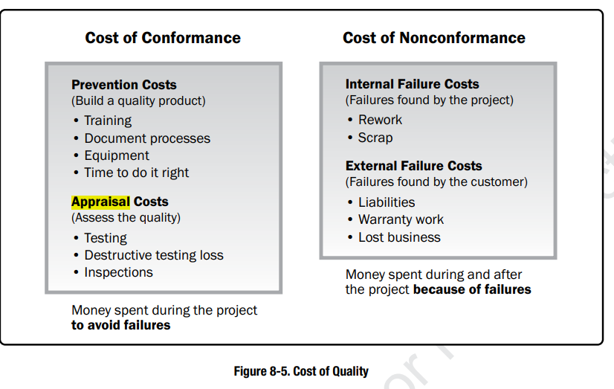
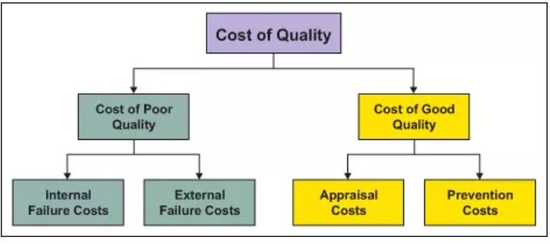
Request 3 👍

Quality Assurance (QA) Activities
Process to Manage Bugs/ Defects
Purpose: Ensure that identified bugs/ Defects are documented, tracked, and resolved efficiently.
When: Throughout the development and testing phases.
How: Use a bug-tracking tool (e.g., Jira) where developers, testers, and stakeholders log bugs. Categorize bugs by priority and assign them to appropriate team members with deadlines for resolution.
Process for Change Requests (CR)
Purpose: Manage requested changes to ensure they are reviewed, prioritized, and implemented without disrupting the project.
When: When any new requirement or modification arises during the project.
How: Define a clear CR workflow: submit a request → analyze impact → approve/reject → implement → verify changes. Use tools like Confluence or custom workflows to document the process.
Quality Cost Delivery
Dev -> Ver -> Prd
Dev -> Prd
Process Design for Basic Design
Purpose: Ensure that the basic design phase follows a structured approach, minimizing errors in initial requirements and design stages.
When: During the initial design phase.
How: Use collaborative tools for documentation (e.g., Lucidchart, Figma) and conduct peer reviews of design documents to validate alignment with project requirements.
Code Review Process
Purpose: Identify and resolve issues in the codebase early to maintain coding standards and prevent defects.
When: During the development phase, before any module is merged into the main branch.
How: Implement a peer-review system where developers review each other's code using version control platforms (e.g., GitHub, GitLab). Create a checklist to evaluate code for functionality, security, and adherence to coding standards.
Requirement Validation Workshops
Purpose: Ensure all project requirements are clearly understood and agreed upon by stakeholders.
When: Before the design and development phases begin.
How: Organize sessions with students, faculty, and administrators to review and validate the gathered requirements. Record feedback and incorporate necessary adjustments into the final requirements document.

Quality Control (QC) Activities
Integration Test Implementation
Purpose: Verify that system modules function correctly under simulated conditions.
When: After individual module development.
How: Perform integration testing by combining modules and testing their interactions using automated testing tools like Selenium.
System Test Implementation
Purpose: Test the system as a whole to ensure it meets functional and non-functional requirements.
When: After all modules are integrated.
How: Execute system tests to validate user workflows, performance, and scalability, logging results for any failed cases.
UAT Test Implementation

Purpose: Validate that the system meets end-user requirements and expectations.
When: Before deployment to production.
How: Conduct sessions with a representative group of students and professors to test the system in a simulated real-world environment. Gather feedback and resolve critical issues before launch.
Regression Testing
Purpose: Ensure new code changes do not negatively impact existing functionalities.
When: After every significant update or bug fix.
How: Run a suite of automated or manual tests covering previously working features. Use testing tools like TestNG or JUnit.
UI/UX Validation
Purpose: Confirm that the user interface and experience are intuitive and meet design standards.
When: During system testing and UAT.
How: Use heuristic evaluation techniques and involve designers and end-users to assess the system for usability, accessibility, and consistency.

1 Resource
BA
Quantity 5
Budget : 5000
Dev
Quantity 5
Budget : 5000
Total :

Request 5 :
Early start : ES - Thời gian bắt đầu sớm nhất của 1 activity
Early finish : EF - Thời gian kết thúc sớm nhất của 1 activity
Late Start : LS - Thời gian bắt đầu muộn nhất nhất của 1 activity
Late Finish : LF - Thời gian kết thúc muộn nhất của 1 activity

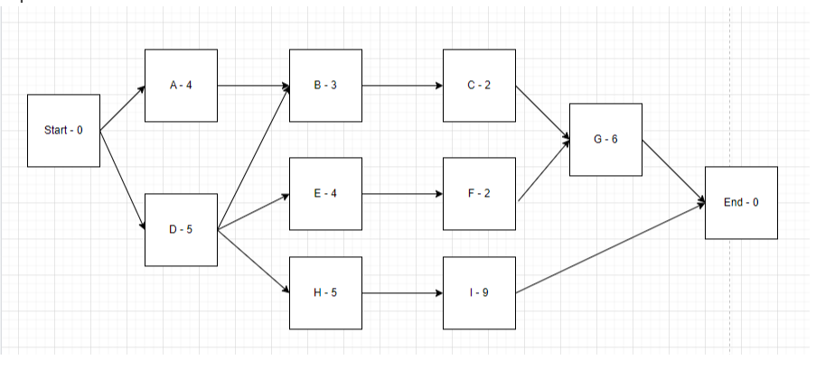
Forward pass : giúp mình xác định được ES, EF của từng đầu việc, và minimum duration for the project
Backward pass : tính được LS, LF
Float : bằng LS - ES bằng LF - EF

- Path 1: Start -> A -> B -> C -> G -> End: 15 weeks
- Path 2: Start -> D -> B -> C -> G -> End: 16 weeks
- Path 3: Start -> D->E->F->G->End: 17 weeks
- Path 4: Start -> D->H->I->End: 19 weeks

The critical path is path 4 . Minimum duration of project is 19 weeks .

Currently the project is working on task D and is 3 weeks late, so the new duration of the each paths is: (task D in path 2,3,4 so it will impact the initial duration of path 2.3.4)
- Path 1: Start -> A -> B -> C -> G -> End: 15 weeks
- Path 2: Start -> D -> B -> C -> G -> End: 19 weeks
- Path 3: Start -> D->E->F->G->End: 20 weeks
- Path 4: Start -> D->H->I->End: 22 weeks
If you want to shorten the project time by 3 weeks which means the duration after deducting 3 weeks is 19 weeks , no path can exceed this number
First of all, when calculating the activity to reduce the duration, you must first consider all the tasks in the critical path - the path with the longest duration, but now & weeks have passed (now you are on task D), so we have only the way to shorten the time in tasks H, I.
The remaining suitable choice is task I because it has a duration of 9 weeks so it is chosen to shorten the duration. So we will plan to shorten task I from 9 weeks to only 6
weeks (9 - 3 = 6).
But after the critical path has been reduced to 19 weeks, path 3 still exceeds this new duration (path 3 duration is 20 weeks). Clearly, we must reduce path 3 by 1 week. Task G should be selected to be reduced by 1 week because it has a longer duration than tasks E and F.
In short, to shorten the project duration by 3 weeks, we have to shorten task I by 3* weeks and task G by 1 week.
Solution 1: Add people to join project to complete task I earlier than 3 weeks, task G earlier than 1 weeks
Solution 2: Force team to work overtime on task I and G
Solution 3: Reward team if they can complete task I earlier than 3 weeks, task & earlier than 1 week
All three ways will cost more cost
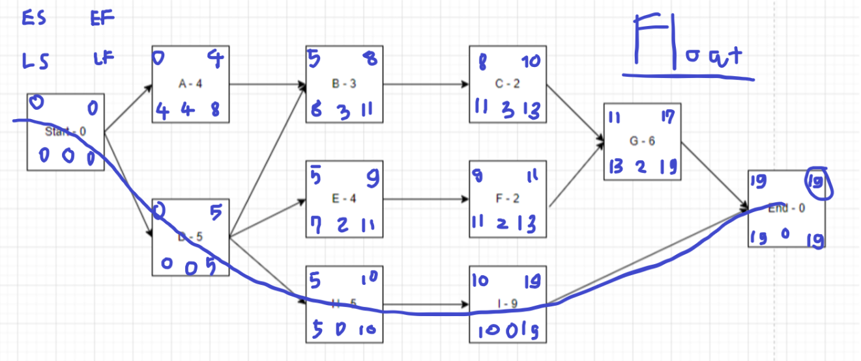
Request 5 👍
Request 5: Project Scheduling - xem thêm ở record 1
predecessor activity
network diagram

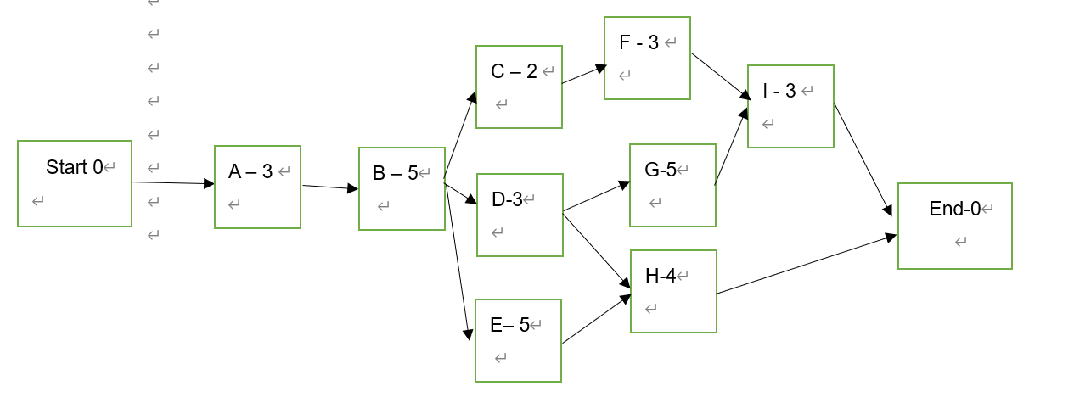

Minimum duration of the project is the longest path
duration of project

Path 1 : Start -> A -> B -> C -> F -> I -> End Duration 16 weeks
Path 2: Start -> A -> B -> D -> G -> I -> End Duration 19 weeks
Path 3 Start -> A -> B -> D -> H -> End Duration 15 weeks
Path 4 Start -> A -> B -> E -> H -> End duration 17 weeks

Critical path method - Critical chain method

So the critical path is path 2 Start -> A -> B -> D -> G -> I -> End Duration 19 weeks
The minimum duration to complete this project is 19 weeks .

Critical Chain Method (Cách vẽ nâng cao)
ES early start : thời gian bắt đầu sớm nhất có thể
EF Early finish : thời gian kết thúc sớm nhất có thể
LS Late start : thời gian bắt đầu muộn nhất
LF Late finish : thời gian kết thúc muộn

Forward pass
backward pass
Float = LS - ES = LF - EF
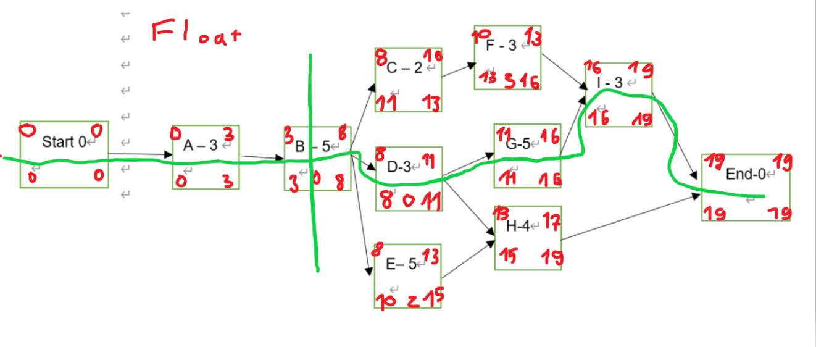

Answer:
Currently the project is working on task B and is 3 weeks late, so the new duration of the each paths is:
Path 1 : Start -> A -> B -> C -> F -> I -> End Duration 19 weeks
Path 2: Start -> A -> B -> D -> G -> I -> End Duration 22 weeks
Path 3 Start -> A -> B -> D -> H -> End Duration 18 weeks
Path 4 Start -> A -> B -> E -> H -> End duration 20 weeks
If you want to shorten the project time by 3 weeks which means the duration after deducting 3 weeks is 19 weeks , no path can exceed this number. First of all, when calculate the activity to decrease the duration , you have to consider firstly all the task in critical path- the path that has longest duration , but now 8 weeks have passed, (now you’re in task B and ), so we only have a way to shorten the time in task D, G, I . The appropriate choice is left with task G because a task with a duration of 5 weeks should be prioritized to shorten the time. So we will have a plan to shorten task G from 5 weeks to only 2 weeks .
But after the critical path had been reduced to 19 weeks, Path 4 is still exceeding this new duration (path 4’s new duration is 20 weeks) . Obviously, we have to reduce path 4 by 1 week . Task E should be prioritized to reduce 1 week as it has a longer duration than task H.
Briefly , in order to reduce the project duration by 3 weeks, we have to shorten task G by 3 weeks and task E by 1 week.
The shortening method is as follow:
Crashing method
- Solution 1: Add people to join project to complete task G earlier than 3 weeks, task E earlier than 1 weeks
- Solution 2 Force team to work overtime on task G and E
- Solution 3 Reward team if they can complete task G earlier than 3 weeks, task E earlier than 1 week
-> Crashing will increase cost.
Or Fast tracking method
Solution:
Let task G overlap task D, after starting task D, start task G immediately, it will help recover the time of path 3 faster by 3 weeks to 19 weeks
Let task H overlap task E for 1 week. After task E has run for 4 weeks, start task H immediately, it will help recover the time of path 4 faster by 1 week to 19 weeks
-> after completing these 2 steps, the project time will return to 19 weeks

